IT Audit Capacity Building

Country Report: SAI Indonesia

Introduction
SAI Indonesia (BPK) was established on January 1, 1947. Its main duty is to perform auditing on management and accountability of the state finances (public funds). Article 23(E) of the 1945 Constitution stipulates the mandate clearly as follow:
“To audit the management and accountability of state finance, there shall be a Supreme Audit Board which shall be free and independent.”
To execute the mandate, BPK has numerous regulations as the legal basis for its operations. These following acts give BPK a rule of games in conducting a government auditing.
- Act No. 17 Year 2003 regarding State Finances;
- Act No. 1 year 2004 regarding State Treasury;
- Act No.15 year 2004 regarding Audit on Management and Accountability of State Finance;
- Act No.15 year 2006 regarding Supreme Audit Institution
By Act No.15/2006, BPK should establish a regional office in each province. Now, BPK has established 34 regional offices all over Indonesia plus one headquarters office in capital city, Jakarta.
In state level institutions, BPK is among the State Institutions together with the President, Parliaments, and the Supreme Court. Holding this position, BPK gains a considerable level of independence from the executive as well as legislative powers to fulfill its duties. Also, BPK holds the highest authority to conduct government auditing on central and local government.
BPK recognizes three types of audit, i.e., financial audit, performance audit, and special purpose audit. Through the financial audit, BPK is the only institution that has an authority to give an audit opinion on both central and local governments. BPK assesses the 3E aspects of government projects and recommends some initiatives for the improvements. The special purpose audit could be either a compliance audit or an investigative audit.
As the holder of authority to conduct audit on government institutions and state-owned-enterprises, BPK is the institution with the extensive use of information to produce new information through a series of audit process. The sufficient information enables BPK to run the mandate in an effective and efficient process.
Realizing that the Information and Communication Technology (ICT) becomes more and more affordable for all level of government institutions, BPK should improve its capacity on IT Audit. As of Q1-2018, during the Financial Audit on Central Government, it is acknowledged that all 88 central government institutions are able to produce Unaudited Financial Report using Government Financial Information System without any off-system procedures. Since the auditee has utilized information system in processing the financial transactions, the knowledge on IT Audit is essential for all auditors of BPK.

IT Audit Capacity Building
ICT grows continuously and so does the IT Audit. In Institutional Development Plan 1996-2000, BPK put IT Audit Capacity Building as a strategic initiative. Since 2001, this initiative has been transformed from a strategic initiative into an operational initiative, which is repetitive every year, as described by the following diagram.
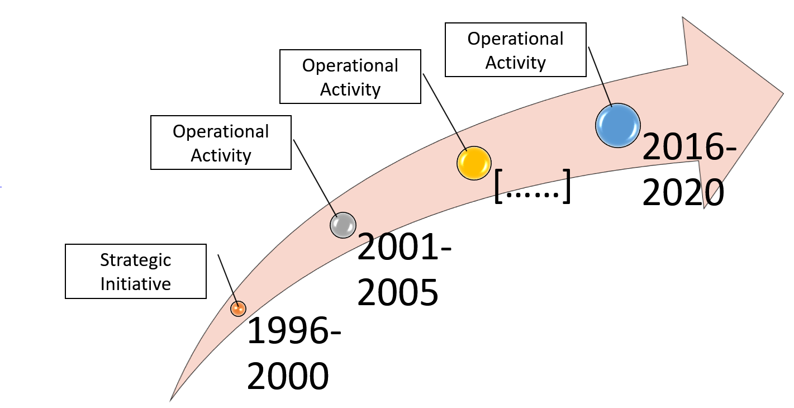
The IT Audit Capacity Building Program targeted three aspects of capacity building, i.e., People, Process, and Technology.

People
Since year 2001, BPK’s Training Center has selected Introduction to IT Audit as a mandatory course in the Junior Auditor Course. This course is one of the requirements for new employees in BPK to become an Auditor. Currently, BPK has 23 CISA holders whose positions are scattered in some regional offices and headquarters. This number will be increased continuously until 2020. IT Bureau hold the responsibility to maintain their accreditation and their knowledge. Therefore, there is a plan to relocate them from current position to the new position in IT Bureau, especially in IT Audit Support unit. Next year, expectedly, BPK will have a functional position named IT Auditor in an official job family.
In addition to increasing the quantity of CISA holder, BPK sent the auditors to the IT Audit Courses held by local training provider or abroad such as India, Australia, and Malaysia. In the past, SAI India regularly offered other SAIs, an iCISA program which train auditors about IT Audit. Also, SAI Malaysia offered other SAIs a similar program related to IT Audit. BPK participated in these events per their invitation.

Process
In 2014, BPK has established a division named IT Service and Audit Support under Information Technology Bureau. This division can be regarded as a pool of IT Auditors in BPK. By design, an audit unit that requires IT Audit practices should submit the request for IT Auditor to IT Bureau. Then, IT Bureau assign at least one auditor from IT Audit Support unit plus one or more IT Specialists based on the expected skill for supporting an audit. For example, an audit that require a technique of source code review may expect IT Auditors that have a programming skill.
In 2016, BPK has developed the IT Audit Guideline. This guideline provides the auditor with a basic principle of IT Audit. The guideline adopted ISSAI 5300: A Guideline on IT Audit. Similar to ISSAI 5300, BPK’s IT Audit Guideline exposed the IT Audit practices under an assumption that the IT Audit is the supportive of three types of audit, i.e., financial audit, performance audit, and special purpose audit.
In addition to BPK’s IT Audit Guideline, IT Bureau is developing several supplementary guidelines for more specific IT Audit practices. It adopts WGITA-IT Audit Handbook. This supplementary guidance may help IT Auditors to examine specific area in IT Environment such as IT Governance, IT Security, Application Control, and IT Operation.

Technology
To support IT Audit team, BPK has procured several licenses of Generalized Audit Software, i.e., ACL and IDEA for Windows. Currently BPK has 500 licenses of ACL and 100 licenses of IDEA. This software was distributed to BPK’s Auditors in regional offices and headquarters. Supported by BPK’s Training Center, IT Bureau periodically trains auditors to use such audit software under the course of Computer-Aided Audit Technique (CAAT).
In 2010, BPK commenced the development of nation-wide project called e-Audit. Through e-Audit, all auditee transmits their financial transaction electronically to BPK’s Data Center using secured Internet access. Currently 500+ auditees have connected to BPK’s Data Center under e-Audit Program. The regular data transmission from auditee to BPK has gradually established a VLDB (Very Large Data Base) in BPK. The VLDB infrastructure hosts huge database come from Ministry of Finance and other Ministries including Local Government. Using special software for processing huge database, IT Bureau developed an automatic analytic procedure to help auditors conducting desk audit using ICT. This will reduce the time needed to run many tasks which are identical among audit team.

IT Audit Experiences
BPK has experienced IT Audit practices in several audit assignments. All these IT Audit Practices are commonly a part of audit types; financial audit, performance audit, and special purpose audit. For financial audit, BPK assign an IT Audit Team as a sub-team of Financial Audit Team. However, it depends on the size of Audit Entity. Especially for small auditee, IT Audit Team may not be necessary assigned as a sub-team but just a team member. Following are the list of IT Audit practices in three types of audit.
- As a sub-team in an Audit Team of Financial Audit on Central Government Financial Report, regularly, since 2004.
The main objective of IT Audit sub-team is to examine specific areas such as Development and Acquisition, Outsourcing, and Application Control, to find sufficient evidence that support audit assertions which is very specific for financial audit.
- As a sub-team in an Audit Team of Performance Audit on e-KTP (Electronic ID Card), Ministry of Internal Affair, in 2012.
The main objective of IT Audit sub-team is to examine specific areas such as IT Performance of e-KTP system, Development and Acquisition, Outsourcing, and Application Control, to find sufficient evidence and to recommend some initiatives for improvement.
- As a sub-team in an Audit Team of Performance Audit on Management of Citizen Identity, Ministry of Internal Affair, in 2017.
The main objective of IT Audit sub-team is to examine the data integrity and data quality of residential identity number, to find sufficient evidence and to recommend some initiatives for improvement.
- As an additional team in an Audit Team of special purpose Audit on the implementation of e-catalogue system, Government Procurement Policy Agency, in 2017.
The main objective of IT Auditor is to examine the source code of application, data integrity and data quality of published products. This team implemented a big data analytics technique for collecting unstructured data from vendor websites to find sufficient evidence for generating an audit conclusion.

Conclusions
Due to the rapid development of ICT, not only private sector but also public sector has put ICT as a driver for improving and streamlining the business processes. SAI as the highest institution for auditing government institution should improve the IT Audit capacity so that there is no significant gap between auditor capability and auditee’s ICT-based business process.
SAI Indonesia has experienced several IT Audit practices ranged from examining data integrity, data quality, and procurement analysis to implementing an innovative audit technique which is beyond Computer-Aided Audit Technique. SAI Indonesia has realized that knowledge on Big Data Analytics become essential to interrogate the financial-related data and information, both structured and unstructured, stored on the cloud.

